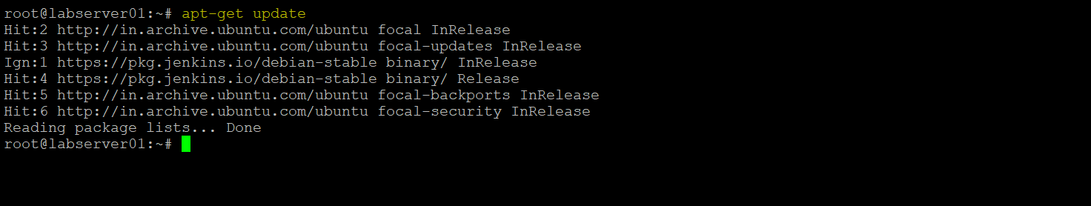

sudo apt install openjdk-11-jdk

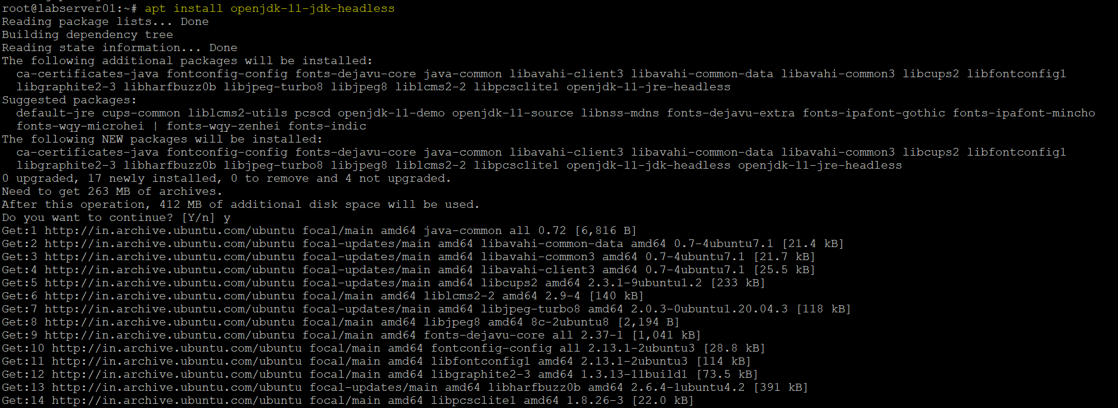

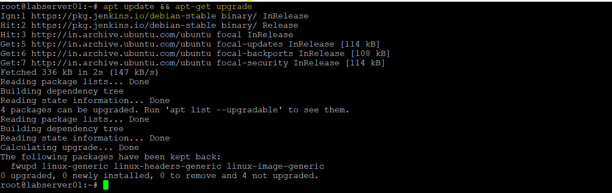

wget -p -O - https://pkg.jenkins.io/debian/jenkins.io.key | sudo apt-key add -



sudo sh -c 'echo deb http://pkg.jenkins.io/debian-stable binary/ > /etc/apt/sources.list.d/jenkins.list'



